

Assessment Cover Page
Student Full Name
Oleksii Taranov
Student Number
Sba26106
Module Title
Strategic Thinking
Assessment Title
CA-1 Capstone project proposal
Lecturer/Supervisor
Taufique Ahmed
Assessment Due Date
25/10/2026
Date of Submission
24/10/2026

GitHub repository
https://github.com/sba26106-bit/strategic-think-ca1

Use of AI Tools
I acknowledge the use of Claude, Grammarly, Google Translator for the purpose of brainstorming, code debugging, translating text and checking the grammar.
Declaration
By submitting this assessment, I confirm that I have read the CCT policy on academic misconduct and understand the implications of submitting work that is not my own or does not appropriately reference material taken from a third party or other source.
I declare it to be my own work and that all material from third parties has been appropriately referenced.
I further confirm that this work has not previously been submitted for assessment by myself or someone else in CCT College Dublin or any other higher education institution.

Abstract

[NOTE: This section is designated for the abstract. Abstracts are not assigned page numbers and should precede the table of contents. If an abstract is unnecessary for your work, please delete this page.]

Contents

1. Project Title 1
2. Introduction 1
3. Problem Definition 1
4. Aim and Objectives 2
5. Scope 2
6. Methodology 2
7. Data Sources 2
8. Expected Deliverables 2
9. Project Timeline 2
10. Ethical and Legal Considerations 2
References 2

[NOTE: The table of contents above has been included for your convenience. To refresh the table, simply click on it, then select 'Update Table' using the mouse. You can choose to update either the page numbers exclusively or the entire table as needed.]

Project Title
Predicting the Orbital Lifetime of Defunct Satellites and Rocket Bodies in Low Earth Orbit to Help Operators Comply with the Five-Year Disposal Rule.

Introduction
Low Earth Orbit (LEO) is where most broadband, navigation and Earth-observation satellites operate, and it is getting crowded. About 40000 objects are now tracked around Earth, and only about 11000 of them are working satellites (European Space Agency, 2025). The rest are defunct satellites, used rocket bodies and fragments. Collisions and explosions now create new debris faster than the atmosphere removes old debris (European Space Agency, 2025). Kessler and Cour-Palais (1978) warned that this could become a chain reaction of collisions.
Regulators have responded with stricter disposal rules. The US Federal Communications Commission (FCC) now requires satellites below 2000 km to leave orbit within five years of the end of their mission. The earlier benchmark was 25 years (Federal Communications Commission, 2024). ESA applied the same five-year limit to its own mission in 2023 (European Space Agency, 2023).
This creates a practical problem for satellite operators. When a mission ends, the operator must decide whether the satellite will re-enter within five years on its own or needs a disposal manoeuvre to lower its orbit. The manoeuvre uses fuel that could otherwise extend the mission. A wrong estimate therefore either wastes fuel or leaves an object that breaks the rule. The difficulty is visible in the numbers: about 90% of rocket bodies in LEO meet the 25-year standard, but only about 80% meet the five-year one (European Space Agency, 2025).
Orbital lifetime is difficult to estimate. It depends mainly on the object’s altitude, its mass and size, and solar activity, which changes how much drag the upper atmosphere produces. This project uses more than 60 years of publicly available tracking records to build a model that predicts how long an uncontrolled LEO object will stay in orbit. The intended users are operators and licensing authorities who need to check a mission against the five-year rule.

Problem Definition
The business problem is uncertainty about how long an object will remain in orbit. A satellite operator or launch provider must judge whether hardware left in a given orbit will re-enter within the five-year limit. A regulator must then check that judgement.
Orbital lifetime depends mainly on three factors: the object’s altitude, its mass and size, and solar activity. A light object with a large surface is slowed by the atmosphere faster than a heavy, compact one. Solar activity heats the upper atmosphere and makes it expand, which increases drag. The effect can be large. In February 2022 a geomagnetic storm increased drag at low altitude, and 38 of 49 newly launched Starlink satellites were lost (Fang et al., 2022).
Lifetime is currently estimated with physics-based tools such as OSCAR, the lifetime module of ESA’s DRAMA suite (Braun et al., 2020). These tools need the object’s mass and cross-section area, and a drag value fitted to its tracking data. The results remain uncertain: ESA applies a margin of ±20% of the remaining lifetime to its own re-entry predictions (European Space Agency, 2018).
Data analytics and machine learning tools can add evidence from how similar objects have actually decayed. Tracking catalogues hold millions of orbit records covering more than 60 years, and the actual lifetime is known for every object that has already re-entered. A model trained on these records can estimate the remaining lifetime of an uncontrolled LEO object and the probability that it re-enters within five years. It can also report how uncertain each estimate is. Future solar activity cannot be forecast reliably (European Space Agency, 2018), so long-range estimates will remain uncertain. The result is a fast screening tool that supports physics-based analysis and does not replace it. Operators could use it to decide whether a satellite needs a disposal manoeuvre at the end of its mission. Regulators could use it to check whether objects already in orbit will meet the five-year rule.

Aim and Objectives

Aim
To develop and evaluate a predictive model that estimates how long an uncontrolled LEO object will remain in orbit, based on its current orbit and solar conditions, and to test how reliably the model identifies objects that will re-enter within the five-year disposal limit.

Objectives
- Build one cleaned and labelled dataset that combines orbit-history records, re-entry dates, daily space-weather data and object properties.
- Analyse how remaining lifetime changes with altitude, drag, object type and the phase of the solar cycle.
- Select and test suitable predictive models, and choose the model with the best accuracy and other evaluation measures.
- Test the selected model’s five-year compliance decisions on objects and later years not used in training.
- Deliver an interactive dashboard that shows the estimated lifetime and compliance probability for a selected object or orbit.

Hypothesis
H1: a model that includes solar-activity features known at the time of prediction (F10.7 solar flux and the Ap geomagnetic index) predicts lifetime more accurately on unseen objects than the same model using only orbital and drag features. H0: adding these features does not improve accuracy.

5. Scope

Included
- tracked objects whose whole orbit lies below 2000 km;
- rocket bodies, mission-related objects, debris, and satellites whose mission has ended;
- natural, uncontrolled decay in orbit records from 1959 to 2026.

Excluded
- satellites that still manoeuvre, because raising the orbit interrupts natural decay;
- controlled re-entries, object above LEO and objects too small to track;
- re-entry locations, break-up, ground risk and operational re-entry warnings.

Methodology
The project follows the CRISP-DM process (Wirth and Hipp, 2000), because its iterative cycle suits a two-semester build.

Data Preparation
Each observation is one object’s orbit on a given date, labelled with the days remaining until re-entry. Records are filtered to LEO and thinned to one per object per week, because consecutive records are nearly identical. Solar flux and geomagnetic activity are joined by date, using only values available on that date, so no future information reaches the model. The features are perigee and apogee altitude, eccentricity, inclination, the drag term and decay rate from the orbit record, object type, and solar activity averaged over the preceding 81 days.

Analytics
Kaplan-Meier survival curves and log-rank tests compare lifetimes across altitude bands, object types and solar-cycle phases.

Predictive modelling
Many objects are still in orbit, so their final lifetime is unknown. Survival methods are designed for such censored data. A Cox proportional-hazards model on perigee altitude alone is the baseline. Random survival forests (Ishwaran et al., 2008) and gradient-boosted trees capture non-linear effects. Models are compared using the concordance index and, for re-entered objects, ESA’s relative prediction error (European Space Agency, 2008). Compliance decisions are assessed with precision, recall and calibration. Data is split by object, never by row, and the final test uses later years than the training data. SHAP values show which factors drive each prediction. The hypothesis is tested by comparing each model with and without solar-activity features on the same folds, using a paired test.

Tools
Python (pandas, scikit-learn, scikit-survival, XGBoost) in Jupiter; DuckDB with Parquet files, with can query hundreds of millions of rows on a laptop without a database server; Streamlit for the dashboard; GitHub for version control. The analysis software is open source, which avoids licence cost and keeps the work reproducible.

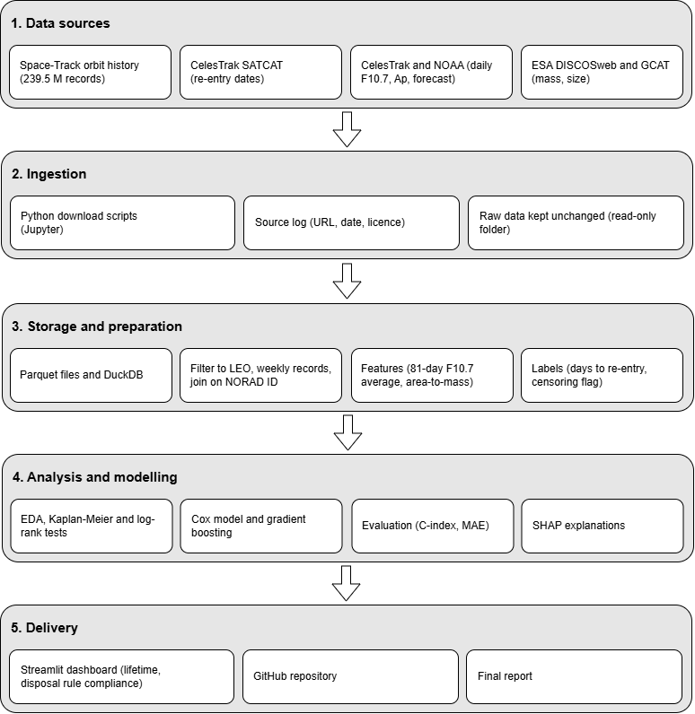
Figure 1. High-level architecture of the proposed workflow

As Figure 1 shows, logged download scripts load the four main sources into Parquet storage, where records are filtered, thinned and labelled. The prepared table feeds the models, and the selected model is reserved through the dashboard.

Data Sources
All data is publicly available and describes physical objects, not people. Orbit history supplies the model inputs, the catalogue supplies the outcome, and space weather supplies the main external driver of decay. DISCOSweb and GCAT supply mass and size for the analysis and the optional pre-launch extension. Table 1 lists each source, its size and the permission to use it.
Table 1. Data sources, content, amount and permissions
Source | Content | Approximate amount | Permission
Space-Track.org orbit history, via a public Parquet copy (Simon, 2026) | Orbital elements, drag term and decay rate for every tracked object, 1959-2026 | 239.5 million records in yearly files (about 12.5 GB) | Basic data redistributable with citation (Space-Track.org, 2026); copy under CC BY 4.0 licence
CelesTrak SATCAT (CelesTrak, 2026a) | Object type, status, size class, launch and re-entry dates | 70882 catalogued objects since 1957 | Free public data; CelesTrak usage policy will be followed; CelesTrak and the original providers will be cited
CelesTrak space weather (CelesTrak, 2026b) | Daily F10.7 solar flux, Kp/Ap indices, sunspot number | About 25000 daily rows since October 1957 | Free public data; CelesTrak and the original providers will be cited
NOAA solar-cycle forecast (NOAA Space Weather Prediction Center, 2026) | Predicted monthly F10.7 and sunspot number | Monthly values for the current solar cycle | US government work (public domain);  NOAA Space Weather Prediction Center will be cited
ESA DISCOSweb (European Space Agency, 2026) | Mass, cross-section and initial orbits of intact objects (no debris fragments) | 51382 matched objects with an initial orbit reaching LEO | Registered account;  ESA DISCOSweb will be cited;  raw data will not be republished
GCAT (McDowell, 2020) | Independent mass and size estimates for cross-checking;  payload end-of-life data | About 70000 catalogued objects | CC BY 4.0 licence;  GCAT will be cited

A feasibility check on one sample year (1990) found 1716288 orbit records for 6800 objects. Of these, 566993 records belong to 2078 objects with a known later re-entry date.
Each object has many rows, one for each weekly orbit record. These rows are not independent, because they describe the same object over time. Therefore, all analysis will group the rows by object. The report will state both the number of rows and the number of distinct objects. The training and sets will be split by object, so that no object appears in both. The statistical tests and Cox model will also treat each object, not each row, as one unit.

Expected Deliverables
By the end of Semester 2 the project will deliver:
- A documented, reproducible data pipeline and cleaned dataset.
- An exploratory analysis with survival curves and statistical tests.
- An evaluated lifetime model, compared with the baseline, and the hypothesis-test result.
- A five-year compliance classifier with calibrated probabilities.
- An interactive Streamlit dashboard for looking up a tracked object.
- A GitHub repository with all code.
- A final report.
- A presentation of project.

References

Braun, V., Funke, Q., Lemmens, S. and Sanvido, S. (2020) ‘DRAMA 3.0 – Upgrade of ESA’s debris risk assessment and mitigation analysis tool suite’, Journal of Space Safety Engineering, 7(3), pp. 206–212. doi: 10.1016/j.jsse.2020.07.020.
European Space Agency (2023) ESA leads the way towards a Zero Debris future. Available at: https://www.esa.int/Space_Safety/Space_Debris/ESA_leads_the_way_towards_a_Zero_Debris_future (Accessed: 5 October 2026).
European Space Agency (2025) ESA Space Environment Report 2025. Available at: https://www.esa.int/Space_Safety/Space_Debris/ESA_Space_Environment_Report_2025 (Accessed: 5 October 2026).
Federal Communications Commission (2024) ‘Space Innovation; Mitigation of Orbital Debris in the New Space Age’, Federal Register, 89(154), 9 August. Available at: https://www.federalregister.gov/documents/2024/08/09/2024-17093/space-innovation-mitigation-of-orbital-debris-in-the-new-space-age. (Accessed: 9 October 2026)
European Space Agency (2018) ESA Re-entry Prediction Front-end User Guide. GEN-REN-MAN-00232-OPS-GR, Issue 0.0. Darmstadt: ESA Space Debris Office. Available at: https://reentry.esoc.esa.int/files/public/GEN-REN-MAN-00232-OPS-GR%20ESA%20Re-entry%20Prediction%20Front-end%20User%20Guide.pdf (Accessed: 11 October 2026).
Fang, T., Kubaryk, A., Goldstein, D., Li, Z., Fuller-Rowell, T., Millward, G., Singer, H.J., Steenburgh, R., Westerman, S. and Babcock, E. (2022) ‘Space weather environment during the SpaceX Starlink satellite loss in February 2022’, Space Weather, 20(11). doi: 10.1029/2022SW003193.

Appendix

If you have used AI tools in your work, you must include screenshots of your requests in the appendix.
The appendix serves as a repository for additional or supplementary information that is deemed too extensive or detailed for integration into the main body of the text. This supplementary content can encompass data tables, charts, graphs, questionnaires, or any other supporting materials that contribute to a comprehensive understanding of the research.
If you haven't used AI tools and there's no need for supplementary data, you can remove the appendix section entirely.

